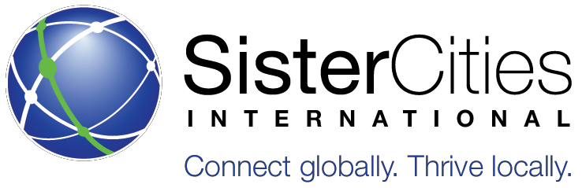
Annual Young Authors Showcase Guidelines
Global Citizens: Resilient Communities

Sister Cities International aims to promote peace through mutual respect, understanding, and cooperation – one individual, one community at a time. This year’s theme, “Global Citizens: Resilient Communities,” highlights the importance of citizen diplomacy and the innovative ways citizen diplomats achieve peace through people-to-people interaction.

Authors are encouraged to draw inspiration from their experiences with sister cities, travel, exchange, international friendships, and the many ways that people cultivate relationships across cultures.

CATEGORIES & SPECIFICATIONS
- Categories: Essay or Poetry.
- Essays are not to exceed 500 words, poetry is not to exceed
200 words.
- Entries must be submitted in English
- Judges will evaluate entries based on theme interpretation, composition, and grammar.
- All work must be original and inspired by the theme.
- All submissions must be emailed to youth@sistercities.org by the April 1, 2019 deadline.
ELIGIBILITY
MORE INFORMATION:
www.sistercities.org/YAAS
youth@sistercities.org
SUBMIT ENTRIES AND ENTRY FORMS
BY APRIL 1, 2019 TO:
youth@sistercities.org
AWARDS
- Judging will take place in late May, and winners and finalists will be announced in June.
- One (1) Grand Prize Winner will be selected from both the poetry and essay categories.
- Each Grand Prize Winner will receive $1,000 cash!
- Two (2) finalists will be selected from both the poetry and essay categories.
- The six (6) winning entries will be published on the Sister Cities International website and will be displayed at the 2019 Annual Conference in Houston, Texas.
- After the Conference, the winning entries will go on a tour to select cities across the U.S.
- Students must be between 13 and 18 years of age at the time of the 2019 deadline.
- The student must be affiliated with a dues-paying member of Sister Cities International or an international community that is sister cities with a
member.
- One (1) entry is allowed per student. Multiple entries are allowed from
each sister city member and their international partners. Please limit five
(5) entries per classroom.
- All entries must conform to Sister Cities International’s policy on plagiarism found at sistercities.org/YAAS.

Annual Young Authors Showcase Entry Form
Global Citizens: Resilient Communities

Please print clearly in English and enclose this form with the essay/poetry
DEADLINE: SUBMISSION MUST BE SENT ELECTRONICALLY TO YOUTH@SISTERCITIES.ORG BY APRIL 1, 2019
Title of Submission
Mailing Address (Street, City, State, Zip Code, Country)
E-mail Address
Phone Number
Full Name (First, Last)

/ /
Birth Date (MM/DD/YY) Gender
Author Information:
How did you hear about YAAS?
Sister City Program Address (Street, City, State, Zip Code, Country)
E-mail Address
Phone Number
Sister City Contact Person
Sister City Program Sponsoring the Entry
Sister Cities Member Sponsor Information:

Please tell us what inspired you to create this work. Continue on another sheet of paper if you need more space.

Signature of Parent/Guardian
Date
Signature of Author
Date
Author’s Waiver

By submitting this entry, I agree to give Sister Cities International, its members and affiliates, permission to publish and display the sub-
mitted entry at public exhibits, online, in publications and/or in promotional materials, at the discretion of Sister Cities International. I agree to abide by all the rules and terms of the showcase and agree to waive all claims of any kind against the showcase organizers.
Send entry form and entry by APRIL 1, 2019 to:
youth@sistercities.org

More information:
www.sistercities.org/YAAS |youth@sistercities.org

