SPRING 2019 ADVENTURE IN ITALY

Come on a Saluda Sister City sponsored for a week in a 1700s refurbished palace and cooking school perched at the very tip top of the hill town of Carunchio in Abruzzo, Italy. Carunchio is Saluda, NC’ss Sister City and we have visited for the past five years. For those who want to come early or stay over, we can point you to great places to stay in Rome, Naples, Sorrento, Montisi, Florence and many other cities. We know a wonderful guide for Rome, one for Siena and several others. We have a connection to a less expensive car rental through major rental agencies that can keep costs down if you want to explore on your own. Italy is very easy and we can offer suggestions. We fly in and out of Rome.

The dates are:

Carunchio, Abruzzo: June 2-8, 2019

You fly out on Saturday, June 1, in the evening and arrive at Rome airport on the morning of Sunday, June 2 . You will be met and transported to Carunchio in a comfortable bus, passing through lovely scenery. The morning of June 8 you will be returned to Rome airport area and spend the night to fly out early the next morning on June 9. We have several recommendations of places to stay near the airport. If there is enough interest, we often arrange an optional private tour of Ostia Antica (www.ostia-antica.org) for the afternoon of the day you return to Rome for those who wish to join in, and a final dinner at a favorite roof-top restaurant, all near the Rome airport.. Then you fly home the morning of June 9. Anyone can come early or stay late and we will provide guidance as needed on tours, locations, guides, rooms, etc.

COST:
The pricing works this way:
2,200 euros if paid via credit card
1,950 euros if paid cash on arrival.
Of course, your deposit is credited against this.
Your host, Massimo, will collect a deposit of $300 in US dollars via credit card which will reduce the amount you pay upon arrival in Carunchio. You will not be charged a fee on this deposit and will get full credit. After the deposit, you will owe 1,650 euros if you pay in euros or 1,900 euros if you pay via credit card. We always buy euros from Bank of America or AAA before leaving but you can also get them from the ATMs in Italy.
There are several premium rooms in the four turret corners of the building which have upgrades and lovely views. They are a $150 euro upcharge. We recommend them, first come-first served. There is also a new “honeymoon suite” across from the palace for a $500 upcharge.
There is a single supplement of 300 euros if you want a private room.
Unlimited red wine is included with lunch and dinner. There is a bar where you can run a tab if you want libations at other times. All are priced very reasonably. Usually on Thursday there are some optional activities if you want to participate….truffle hunting with a truffle dog , a massage, sometimes an art lesson. Those are the only optional extras other than tips for the staff, of course.

Carunchio in Abruzzzo
This village is east of Rome, across the country, almost to the Adriatic, perched on the point of a chocolate-drop shaped hill. The views from the Palace and its patio are breathtaking. There are tiny hill towns all around on the distant hills and snow-capped mountains in the distance. It is definitely a “vertical” town but there is plenty to explore around the very top where it is mostly flat. It dates from 1000 AD and is listed as one of the “100 Most Beautiful Villages in Italy.” It is 35 minutes from the Adriatic and near a number of other towns of interest. Five or so excursions to explore the area are organized for all and us included in the fee. Twelve of us from Saluda and Charlotte went to Carunchio in 2014, 25 went in 2015, 23 in 2016 and 20 in 2018, and many said it was the best trip of their life.

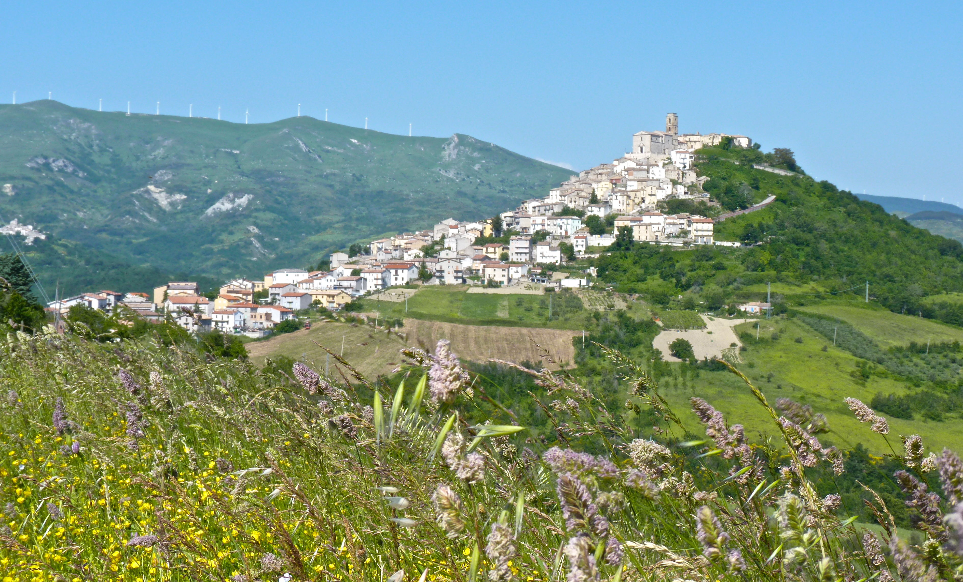

The Palace. Palazzo Tour D’Eau was built by a prestigious French noble family in the early 1700s. It was found and restored by our host’s father and now is used exclusively for groups who come for a week to explore the region, eat incredible food and learn to cook regional specialties. There are 14 rooms, each with private bath. There is a large dining table seating 24 for dinners, cozy 8-tops in the breakfast area, another large table for 24 in the cooking school where a few lunches are served and another large table for 24 on the patio. There is one bedroom on the ground floor and the rest on the second floor (and that honeymoon suite across the parking area). The former cellar below, now the cooking school, boasts a vaulted ceiling, walls covered with beautiful mosaics, a wood fired oven and state of the art cooking fixtures. Entry to this are is outside from the end of the palace at the outside patio area, an easy walk down a sloped sidewalk from the front entrance. No steps.

The Program at the Palace. The Carunchio experience includes transportation to and from Rome, all meals of the most amazing gourmet quality, all the wine you want with lunch and dinner, all the cappuccino you want with breakfast, all the cooking lessons, your room, all the excursions, all transportation and Massimo’s smiling face and fun commentary. Last year the excursions included a vineyard and explanation of wine-making, an olive grove visit with tasting and explanation of the oil extraction process, the second largest bell foundry in the world, a cheese making factory, guided tour in the historic town of Vasto on the Adriatic and its beach, and the most amazing visit to an historic fish house perched in the Adriatic with a seafood meal never to be forgotten! There is also a class in wine tasting and pairing with Massimo, a certified Italian sommelier. He and his family own their own vineyards and produce wonderful wine. We are working with Massimo to create this year’s tours and, once we know who is attending, we may be able to honor areas of particular interest. The cooking lessons are great fun and you come home with useful recipes. Even a few men who swore that were not interested in cooking joined in and loved the experience. . The lessons are in the former wine cellar below the palace. It is large and bright and there is usually beer or wine down there when we need it.

Websites of Interest:
http://www.palazzotd.com This is the main website for the Palace and its programs
http://abruzzocibus.com Lots of info about the whole experience with a video by Massimo. Highlights the cooking, personnel, tours, etc.
http://www.tripadvisor.com/Hotel_Review-g1052388-d1052394-Reviews-or10-Palazzo_Tour_d_Eau-Carunchio_Province_of_Chieti_Abruzzo.html#REVIEWS Trip Advisor Reviews

HERE’S WHAT YOU HAVE TO DO IF YOU THINK YOU MIGHT WANT TO GO:
- Read everything and look at the websites.
- Email or call me with any specific questions
- Make a decision as soon as possible. If we haven’t filled all the rooms by December 30, we will release them and Massimo will try to fill the remainder.

Once we know you are interested we will answer any general questions about the Carunchio trip and provide any additional information you need on how to spend extra days in Italy. You will need to make your deposit as soon as you are committed in order to hold your room or no later than January 5. Once you pay, deposits are only refundable if you or Saluda Sister City or Massimo can fill your slot. Every year we have had someone have to cancel and we have been able to fill their slot and get them a refund….not a guaranty but it has worked in the past.
We have to fill the palace to make it cost efficient so please pass this to friends you think will be interested. We will take reservations in the order you give us a definite YES. Folks get room choices in the order that deposits are received. We will attach info on the rooms at the very bottom.

Those of us in Saluda have been to Carunchio many times and guaranty it is an amazing experience. It is a very easy trip as everything is done for you for a fixed price. You just go to breakfast in the morning and look at the board so see what is in store for the day. There is one room on the lower floor for those who are challenged by steps. But there is no extensive walking unless you elect to do it on your free time.

So, email Saluda Sister City and let us now if you want more information and how interested you are. If you email, put ITALY in the subject line. If we don’t hear from you, we will assume you are not interested, but please pass this info along to friends who may want to join us.

Judy Thompson
Saluda Sister City Chair
jdt@JDThompsonLaw.com
828-489-6578

ROOM INFO:

You will only be in your room to sleep so please don't get stressed over what room you get. Below is a list of the rooms and they will be chosen on a first come, first served based on receipt of deposits. If you don't care what room, just say no preference. If you want a specific room, let us know your preference and we will let you know if it is available or already taken. If you opt for one of the rooms with a surcharge, you will pay that in Carunchio. Note, if you are in a single room, there is a $300 single room fee. If you have knee or hip problems, consider the downstairs room. Remember that this was built as a palace...a very fancy home. The family rooms have been divided up to make bedrooms, and bathrooms have been added so each room has a private bath. There is a group of rooms up on the second floor that has a nice sitting area outside of it. We usually put groups who are travelling together in those rooms so they have a handy sitting area that they can use to visit together. There is also a living room type area downstairs as well as the cozy bar. All are open to anyone.

Premium Rooms:
There are several premium room, four of which are in the four turret corners of the building. All of these have upgrades and lovely views out across the countryside. They require a 150 euro upcharge as they are the best rooms. There is also a very private “honeymoon” suite for a 500 euro upcharge. They are first come-first served, so please let me know if you want one of these rooms:
Room A. Turret room with town view. King bed. This was my room the first year. Right front of palace
Room 4. Turret Room with beautiful view from bedroom and bathroom out over the valley. Left rear of palace. King Bed.
Room 5. Turret Room, Right rear of palace, largest room with a splitable bed and a single.
Room 2. Turret room with valley and town view. Left Front of Palace. King bed.
Room 1 with splitable beds is only room with tub (and shower in the tub). This is not a turret room but is an upgraded room for the extra 150 Euro. Has view.
HoneyMoon Suite: The new honeymoon suite is an external cottage, situated outside of the palazzo (right across the small street). It’s three times bigger, with an open space studio, a large bathroom, beautiful view, patio and espresso machine. The extra charge is 500 extra euros.

Other Rooms:
Room 6, large room with splitable beds and town view.
Room 7, only room with a little balcony (it is over front door), has splitable beds.
Room 8, king bed, town view
Room B, king bed, town and valley view
Room C, splitable beds, only room with windows that face inner courtyard rather than outside. This was my room last year.
Room D, splitable beds with valley and town view.

Downstairs Room (generally used for folks who have trouble with stairs) This does not have large windows with views. It was half of a large parlor that was divided into two rooms.
Room 1, queen bed

