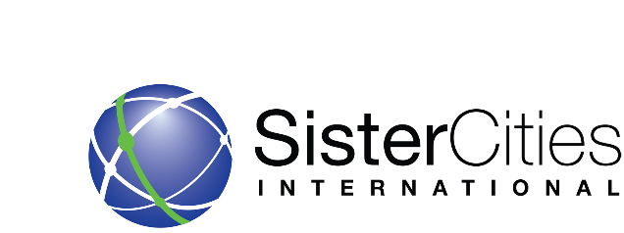
PUBLICITY AND MARKETING TOOLKIT

Overview

To successfully publicize and market your sister city program, members need to keep in mind good performance (a high-quality sister cities program) and good communication with the public. A program needs to have knowledge of its history, current activities, and participants, and the intended audience

One of the most effective ways to get the message out about the mission, activities and events of your sister cities program is to utilize a variety of media outlets:

- Social Media
- Local Media
- Sister Cities Publications
- Community Outreach

Publicizing the Program through Social Media
Online forms of communication, such as Twitter, Instagram, Snapchat, and Facebook/Meta may help you share and promote information about your Sister Cities programs with friends, colleagues, and international partners. Regular posts and updates will help to keep your organization current in the minds of your social media community, and enhance the understanding, support and involvement in your Sister Cities organization.

Publicizing the Program through Local Media
When informing the news media of a potential story, be sure to use one or all of the following techniques to inform the media of program news.

News (or press) release: This is a standard form to inform the media about news from the local program. A news release must be newsworthy, and it must get to the right person at the right time. click here for the How to Write a Press Release Toolkit
Press conferences: This is a meeting called to inform members of the media about an event or situation, and to provide them an opportunity to ask questions.

Direct media contact: Getting to know the reporters and editors personally is the key to many successful publicity campaigns. It makes good sense to do a press release mailing, but even better to follow-up the mailings with a phone call and a personal visit.
Feature Story: Over the years, local sister city programs have had success placing feature stories about their programs in newspapers or on television. A feature story is based more on interest or background than on news. There are no limitations to writing feature stories for the local media. Whenever a member finds something that is interesting to the public, consider submitting it to the editor of the local news outlet.

Other techniques to publicize the organization in the local media:

- Letters to the editor
- Op-Ed Articles on the value of Sister Cities Programs.
- Public service announcements
- Regular or guest column
- TV/radio appearances
- Press kits
- Video news release

Publicizing the program through sister city publications
The writing and production of promotional content is a major activity in most publicity campaigns. Unlike using the media to get the message out, the program has control over what and how it addresses issues in its publications, as well as control over the distribution and the audience.

Newsletters: Either printed or digital or both
Internet
Brochures
Flyers
Reprints/reposts: A popular way to publicize and add credibility to the local program is through reprints and reposts of positive news covering the program.

Publicizing the program through community outreach
There are many outlets for the ongoing promotion of the sister city program. The following list highlights a few ways that the members can garner recognition for its sister city program to increase membership recruitment, promote special events and increase local awareness of the program.

Public speaking engagements: Give public speaking opportunities as often as the program can schedule them. This form of publicity reaches specific audiences, while enabling the program to have complete control of its message. When giving a speech, keep in mind the four basic types of speeches: informative, persuasive, entertaining and technical.

Work with other local organizations: Every service club, women’s group, political party, labor group, religious unit, association, civic organization, veteran’s organization or other group is influential and essential to the program. Each group represents a segment of the community. Make a concerted effort to work with these groups. They can be reached by email, direct mail, speaking engagements, telephoning members or interviewing their leaders.

Hold seminars, roundtables, webinars and workshops: A very effective way of promoting the activities of the programs is to hold informational programs. One advantage is that the program has complete control over the program and the audience invited. A properly planned program gives the audience worthwhile, practical and timely information and knowledge about the organization’s activities and opportunities.

For more ideas, CLICK HERE for examples of 20 Great Publicity and Event Ideas.

