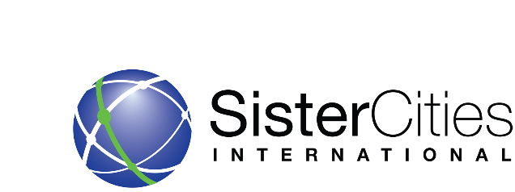
BENEFITS OF MEMBERSHIP FOR GLOBAL MEMBERS

Membership in Sister Cities International is open to cities of all sizes, counties, states, international cities, and individuals. Members are a part of a network of citizen diplomats from over 500 U.S. communities with partnerships in nearly 2,000 cities in more than 140 countries around the globe. Membership in the SCI network benefits your local sister city program in several ways. SCI is the clearinghouse for local programs nationwide, providing services to its members, compiling statistics, promoting the SCI mission, publicizing the efforts of sister city programs, projects and volunteers, recognizing young artists and international scholars and offering various grant programs to its members each year.

Dues-paying global members receive access to:
• Membership Directory: All members and their sister cities are listed in Sister Cities International’s Membership Directory. This directory is the go-to resource for sister city partnerships and can be found on our website. Global Members will have all their international partnerships listed, not simply those with U.S. communities.
• Certificates: Sister Cities International provides certificates to commemorate new partnerships or milestone anniversaries of sister cities at no cost to members.
• Toolkits: Sister Cities International provides best practices toolkits for exchanges, economic development, advocacy, and other topics relevant to sister city development.
• Member Badge: Sister Cities International provides certification to members in good standing to verify they are part of our network of communities. Members have broad usage of our Member Badge in their communications to show they are a part of the largest sister cities network in the world.
• Young Artists and Young Authors Showcase: The Young Artists and Authors Showcase is an art and writing competition among all U.S. and foreign sister cities. Winners are promoted throughout the network and the top selections travel the country for display in various U.S. cities. Sister city programs tap SCI’s resources to find contacts, to network globally and to glean ideas about how to develop projects that benefit U.S. communities and their affiliations.
• Global Conversations and Roundtables: Our Global Conversations and roundtables focus on issues pertinent to citizen diplomats and link cities around the world, including networking with Ambassadors and other diplomats.

• Conferences: Global members are eligible for reduced registration and exhibit fees for regional, national and international conferences, which provide invaluable networking opportunities.

