VIDEO #2: The **HOW (UPDATED SCRIPT)**

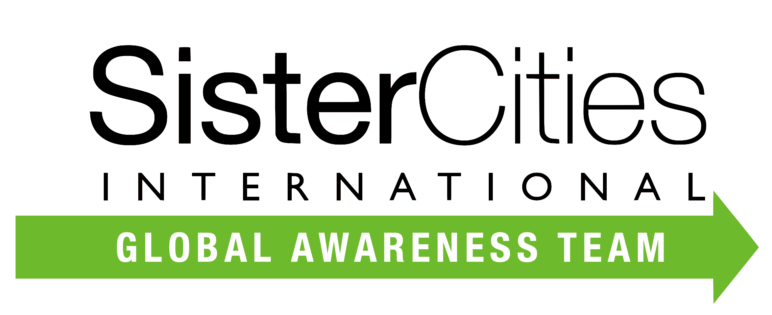

**HOW ARE SISTER CITY PARTNERSHIPS FORMED?**

*A sister city relationship is formally recognized when SCI receives and records a Memorandum of Understanding, Resolution or Proclamation, signed by both Mayors or their Designees.*

*But Finding – and Developing – a Successful Sister City Partnership is a COLLABORATIVE PROCESS.*

Let’s Discuss HOW to Get Started!

**1. RESEARCH**

Sister city relationships are strategic, long-term partnerships that should be mutually beneficial. Identifying potential partners begins with a City’s Self-Assessment to guide the selection process. Often the areas of collaboration can begin with similarities. Such as

* + - **Population size**

# Industries

* + - **Academic institutions**
    - **Cultural institutions**
    - **Preexisting Relationships**
    - **Corporate, Historical or Ancestral connections**

# 2. COMMUNICATION

# The next step is to develop a line of communication with the prospective sister city . Start with a letter of introduction from one mayor to the other. Always follow international protocols to insure a positive experience.

Once communication begins, consider an official site visit, develop dialogues between key stakeholders, and possibly implement a program to “test the waters” like pen pal exchanges, virtual conversations, or community art exhibits.

**3. A PARTNERSHIP AGREEMENT**

The partnership terms are developed by both communities and can include mutual commitment language and specific areas for cooperation and an evaluation period. SCI has many models to share.

**4. THE SIGNING CEREMONY**

It is customarily a formal ceremony, occurring in both cities often with an exchange of official gifts. The **when** and **where** for the ceremonies is determined during the partnership development process. SCI has many ceremony models, and even virtual examples.

**5. MAKING THE MOST OF YOUR PARTNERSHIP!**

The planning of programs, exchanges, visiting delegations and collaborative projects engages the citizens in both communities and brings LIFE to the Partnership.  
 This is KEY to Sister Cities Success!

**CONNECT GLOBALLY , THRIVE LOCALLY**

**WITH SISTER CITIES INTERNATIONAL**