**VIDEO 1: WHY have a Sister City in the USA?**

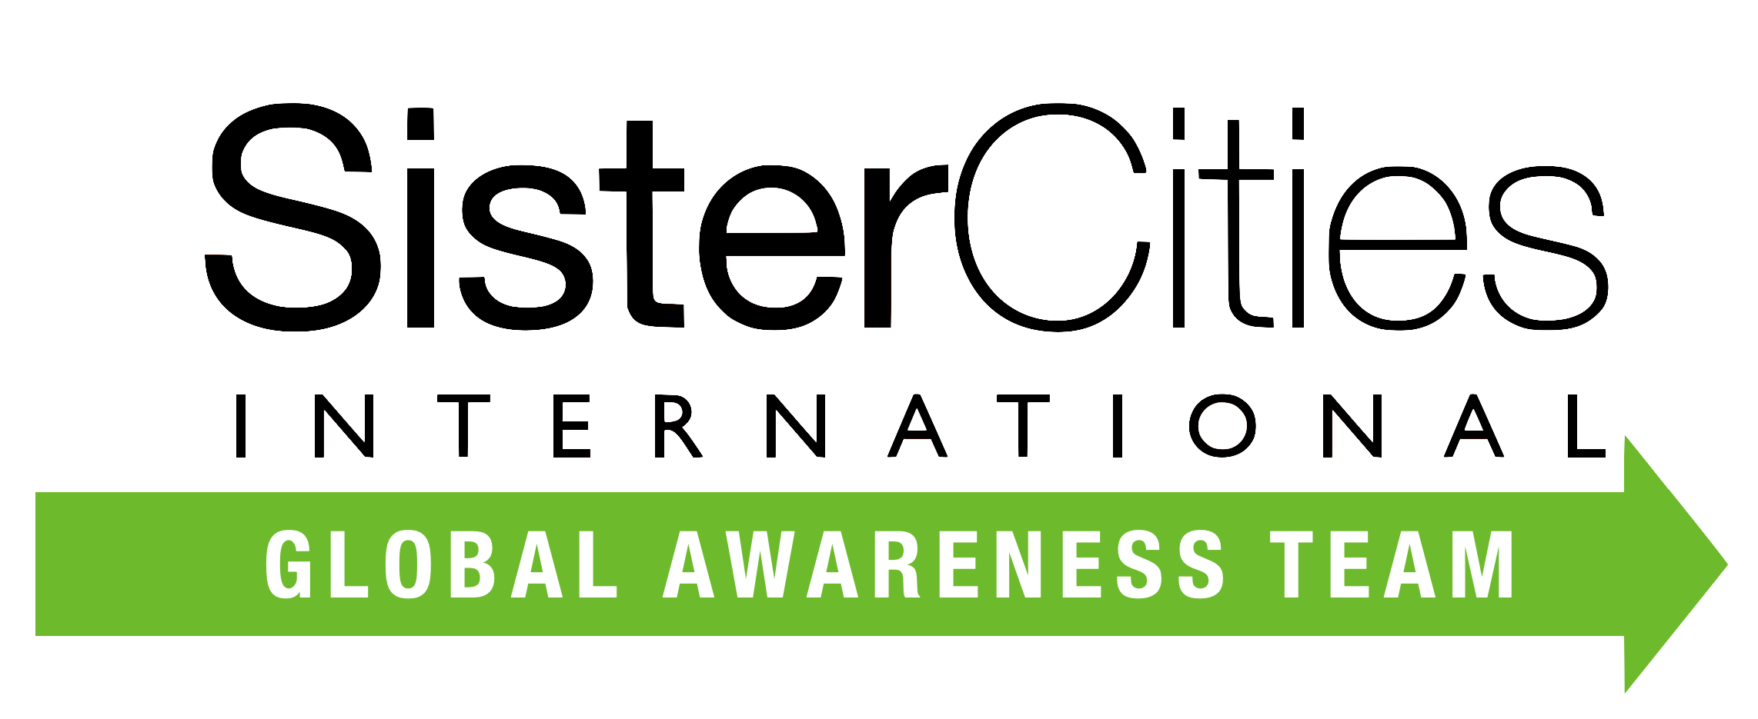

***Key Point:*** *Why does France matter to the US?*

*France is one of the America’s oldest and strongest allies. We share common human values, and France is Europe’s #1 Country for innovative and involved Sister City partnerships. Plus France gave the US its enduring symbol of Hope and Freedom: the Statue of Liberty.*

1. **Let’s Start with ‘What is Sister Cities International?** 

Sister Cities Intl (SCI) is the organizing entity for US Sister Cities. It was founded in 1956 by President Dwight D Eisenhower*.* Now the premier globalorganization for citizen diplomacy with over 450 US Cities in 2800 partnerships in 140 countries of the world. The members are dues paying cities and they elect the governing Board of Directors. SCI is the recorder and poster of official Sister Cities documents.

1. **Why have a Sister City with the US?** 

SCI’s platform motivates and empowers both cities’ local officials to partner internationally to: facilitate their city’s growth agenda; provide education and internships for young professionals and entrepreneurs; provide sports, municipal, health, cultural exchanges; diverse initiatives such as Climate Change, homelessness and most importantly to create citizen and municipal diplomats.

1. **How Can SCI help Mayors?** A picture containing mask, yellow, dark, goggles

   Description automatically generated

SCI’s structure provides State, Regional and Country Representatives that are seasoned in creating Sister City relationships, have templates, guidelines, assessment tools and best practice models. You are listed on www.sistercities.org..

3. Are there local examples of successful Partnerships? 

Absolutely!

* The DENVER, COLORADO -BREST Partnership – established in 1947 –

is one of the most dynamic and successful programs across the globe – with an ongoing focus on excellence and entrepreneurship, through Start Ups or new collaborative exchanges in science, technology, and the environment.

* FORT WORTH, TEXAS AND NIMES, FRANCE are both cowboy and culture capitals. And recently, Fort Worth Docents met with their French “liaisons” to share ideas about guiding tips in their respective cities! (<https://www.fwsistercities.org/city/nimes-france/>

*Need photos of Docents

* SURFING is “on Board” in SANTA CRUZ, CALIFORNIA and-BIARRITZ, FRANCE - where enthusiasts in those Sister Cities focus on healthy ocean sports, beach initiatives, and even UN’s Sustainable water goals. Biarritz is currently testing the only commercially available hydrogen bike!
* <https://surfschoolsantacruz.com/gallery/>
* https://santacruzworks.org/blueinn22
* And the ASPEN, COLORADO-CHIMONEUX partnership means MOUNTAINS –And where Ski Resorts, Ski Patrols, and Winter Skiers take to some of the world’s Most Beautiful Slopes - as well as work together as geographical partners on the dynamics of climate change. s<https://aspensistercities.com> GOOD PHOTOS

<https://www.chamonix.com>

ONLY IF THERE IS TIME:

* The LAGUNA BEACH, CA-MENTON, FRANCE partnership– encourages collaborative exchanges of cultural, educational, and business activities.  The Annual Music Festival attracts a world of talent!

(VIDEO LINK at <https://lagunabeachsistercities.com>)